### Overview

PetFindr is a web app designed by Pet Finders, used to help pet owners track or find their furry friends.

If you are worried about your pet disappearing for long periods of time, worry no more, PetFindr will help you locate your pet, giving you a piece of mind at the touch of a finger.

We are launching an app and web portal, to give pet owners full control of their pet’s location and health from any compatible Smartphone and Devices with ease, and easily be sync to your phone or digital device via Bluetooth and Wifi.

**Key Features:**

* GPS location tracker - Pinpoint your pets’ current locations from anywhere in the world.
* Health tracker - Track your pets heart rate, exercise routines and food intake (for weight gain or weight loss) and steps.
* Geo-Alets - set and receive phone and push notification when your cat leaves an area or Safe Zone.

**About GPS Tracker**

The transmitter is built into the collar, it has a chip inside which acquires the signal broadcast by GPS satellites that orbit the earth to find the pets location. Then, using mobile coverage and/or Wifi connection to send the GPS coordinates to the smartphone or device.

Google Maps Navigation will be integrated into the app and web platform using Google’s APIs, for example, Geocoding and geolocation to help pet owners track their pet’s location in real-time. The Geolocation API returns a location and accuracy radius based on information about cell towers and WiFi nodes that the mobile client can detect, which is useful when GPS is not available.

**About health tracker**

The health tracking feature is like a FitBit for pets. It can monitor your pet’s steps, play time, nap time and temperature, sensors in the wireless device measures your heart rate it features two electrode strips underneath the collar that make contact with your pets’ skin to take the vital readings. The information can then be read via the web platform or app, information is stored securely on the cloud for later access.

**About Geo-fencing**

The GeoFencing feature helps in determining geographic areas and boundaries that your pet is allowed. Geofencing accuracy can reach 100-200 meters, an alert is issued when your pet leaves the area or boundary. Due to GPS inaccuracies, geofencing might not work reliably for pet’s that live in apartment blocks. Why, PetFindr uses a combination of GPS, mobile data, and WiFi data to assist with accuracy.

### Market Research

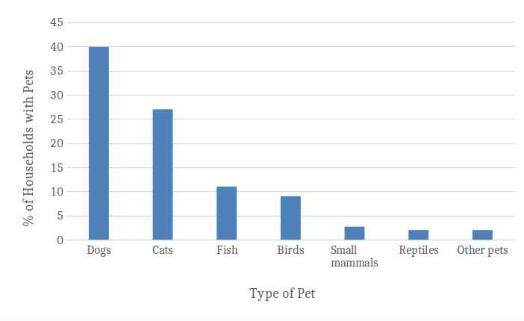There are over 29 million pets in Australia. Approximately 61% of households in Australia own pets, with dogs being the most common (40%), followed by cats (27%). According to the Pet Census report 2016, 1 in 5 pet owners have both a cat and a dog. [3]

**How much do Australians spend on their pets?**

Overall, Australian households are estimated to have spent over $13 billion on pet services and products in 2019 [1]. Dog owners spent the most, with an estimated average of $1627 spent per animal each year. Cat owners spend an estimated average of $962 per animal each year [1].

**Pets & Family**

Animal Medicines Australia say, in 2019, over 60% of dog and cat owners considered their pet as a member of the family. Companionship is the main reason for Australians getting a pet, followed by rescuing animals, being given animals, teaching children responsibility and for relaxation.

**Losing your pet**

Loosing your pet can be a devastating and traumatic experience. Humans tend to develop a lasting attachment with their pets, which breaks at the loss of the pet.

**Stolen/Missing Pets**

A pet detective Anne-Marie told 9 News. "When you find a lost pet, its actually not a case of finders keepers, you actually are required by law to make every attempt to reunite that pet with its rightful owner,".

Anne-Marie said thefts are on the rise right now because there is a supply and demand issue. More people want a pet because the pandemic has left them feeling lonely, and thieves are taking advantage of this by stealing furry friends to sell them for a profit. [2]

### Description

The idea is to launch an app and web portal, designed and developed in Australia. The app gives you full control of your pet’s location and health from the convenience of your Smartphone and Devices with ease. It has a “reminder” feature, allowing you to set alerts for feeding time, playtime, walks, grooming and when they need to take medication etc.

Find My Phone helps you locate your lost Smartphone and get it back, our PetTrackr app is based on the same concept, but uses google maps and Global Positioning System (GPS) technology for real-time or live tracking and seeing location activity, giving you the ability to track your pet and manage your notification settings from anywhere in the world.

The health tracking feature tells you if your pet is too thin, overweight or obese and there’s also a “recommended food and water intake” option that uses data from a range of pet brands and works out how much food your dog would need each day.

The PetTackr is lightweight and durable, it is aim is cover all aspects of your pet’s health and safety. This forms the basis of a health check appointment and reminder service and is really helpful tool for owners and their vets too, vets can use the data to focus on a particular area that requires attention and conduct further tests if required.

Your PetFindr has no range limitations. On the map, you will see your pet’s approximate location. If your pet cannot be found, it will show you the last known location (if available). Pet owners can also setup virtual safe zones and receive notifications when their pet leaves the area, it can also easily be sync to your phone or digital device via Bluetooth and Wifi.

Alarm is sent to your smartphone/device if collar is removed, you can simultaneously lock or unlock the collar at any time, by pressing a button on your smartphone. Notifications and SMS’s can be sent directly to your App and Online Portal. You can also request for SMS to be sent to your friends and family, however for this feature users are required to upgrade their subscription to an SMS pack.

Connectivity is a crucial part of product design and performance and the choice of connectivity technology must be considered early in the process. This is a challenging choice given the quick technology and market development. 2G and 3G networks are starting to be phased out and new 5G network technologies are becoming increasingly popular.

### Features & Benefits

**GPS/WiFi/Bluetooth**

Using cell coverage, the PetTrackr sends **GPS** coordinates to your smartphone and devices. This means you can pinpoint your pet’s current location from anywhere in the world. The PetFindr comes with built-in WiFi and Bluetooth connections and can be easily p**aired to** your phone or other device.

**Health Tracker**

There is a built in Pet Health Tracker to monitor you pets hearts rate, exercise routines and food intake, we have a built-in barcode scanner so you can record nutrition information – and keep a pet food journal.

* **ACTIVITY TRACKING**  
  Monitor your pet’s activity – see changing trends; set activity goals.
* **TEMPERATURE**  
  Monitor your pet’s body temperature with PetTrackr Collar – detect fever, heat stroke, hypothermia, etc.
* **HEART RATE**  
  Monitor your pets (Heart Rate Variability) and for any changes or abnormalities that could indicate pain, stress or underlying disease.
* **CALORIES**  
  Track calories burned by your pet's, water intake and help them in weight loss programs and prevent obesity.

Pet owners can check pet's hydration level and report on the overall health of the pet, as well as store information about vaccinations and next pet appointment reminders.

**Geo-alerts**

Users can set and receive custom phone and push notification when your pet leaves an area and Safe Zone or gets disconnected from your wifi or Bluetooth device.

**LED Light**

There is a built-in LED colour changing light to draw attention to your pet at night, the colour codes are as follows:

Red - when you pet is reported lost/stolen.

Blue - when pet goes outside allocated safe-zone.

Green – when camera is recording.

**Audio/Video**

Monitor your pet remotely and keep them company with a pet camera and built-in speaker allows owners to communicate with their pets from far distances, it is also a useful feature for owners who have pets that have poor hearing.

**Internet/Connectivity**

SIM included, so your device is ready for use out of the box, PetTrackr is 2G, 3G, 4G and 5G compatible and supports both SMS (56 kb/s) and Internet of Things (IoT – 1Gb/s).

### Detail Description

**Topic**

The primary purpose of this project is to create a platform using the latest technologies and trends designed to give pet owners a piece of mind when it comes to the health and safety of their pets.

The process includes building a visual representation of what the app and website will look like, along with a concept of the design for our Pet Tracking Collar.

**Motivation**

The idea came about after one of the group members cat went missing, when he was travelling for work. His friend called to say the kitten has been missing for 24 hours, and the fear was because of the breed, the cat might have been stolen, if only he had put on a tracking device on the collar before he left, he could check the location of his pet remotely.

During COVID-19, a lot of people went out and brought pets, some pets went missing or where stolen, why this project is so important and interesting.

Emerging IT trends in the Pet Industry is wearable monitors, pet owners want to keep tabs on your beloved animal or keep track of an ill pet's vital signs by fitting them with a wearable monitor. Other technology and trends in the industry are, online ordering, webcams and pet profiles on social media.

What would it show to a future employer if you were able to work on this project?

We would show the prototype of the website and app, and digital illustrations of what the pet collar would look like.

**Aim**

Build a state-of-the-art web app and tracking collar, to give pet owners a 360 view of their best friends.

Our goals for the project are:

* Build prototype of key features, such as GPS/MAP, Health Tracker and Geo-alert.
* Provide digital drawings and illustrations of pet tracker collar.
* Creating a video about the product to demonstrate what the app can do.
* Design web app, ensuring the interface is user-friendly and compatible across multiple devices/platforms.
* Develop existing website and include a prototype for the backend login page.